گروه5

سوال 5

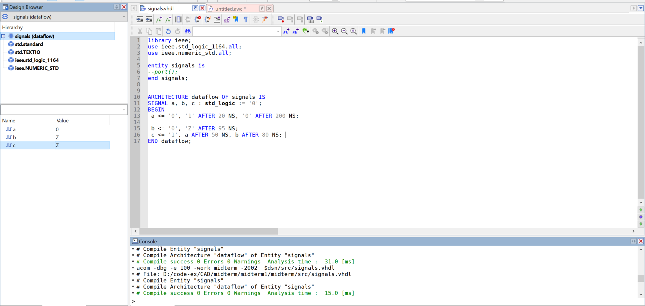

خروجی کد بالا در waveform:

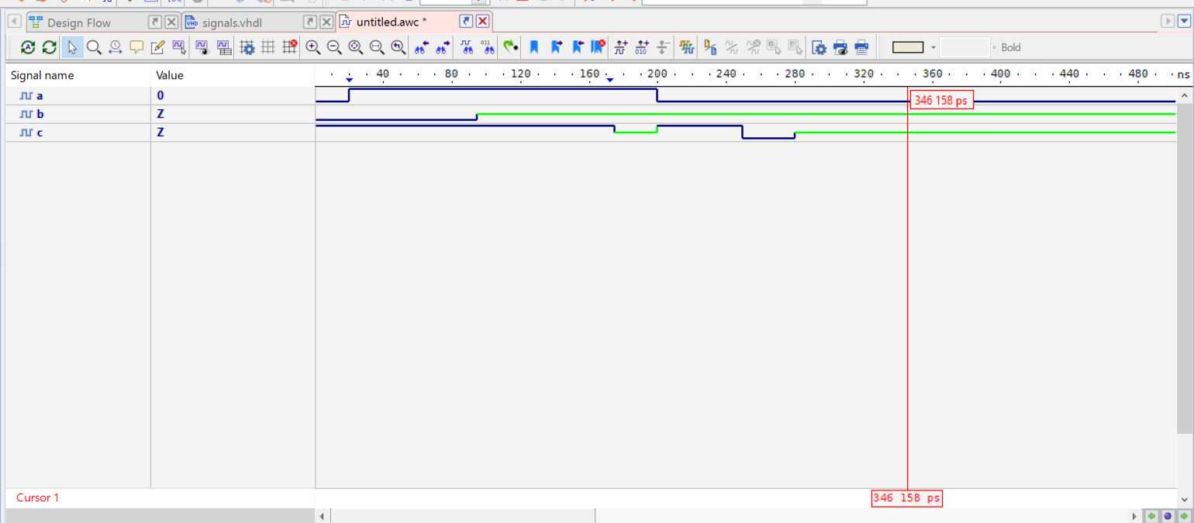

توضیحات تکمیلی:

std_logic is a data type in VHDL that is used to represent digital signals. It is an enumerated type with nine possible values, which are:

'U': uninitialized

'X': unknown logic value

'0': logic 0

'1': logic 1

'Z': high impedance

'W': weak unknown

'L': weak logic 0

'H': weak logic 1

'-': don't care

In digital circuits, signals can be in one of two logic states: high (1) or low (0). However, in some cases, a signal can be in an unknown or high impedance state, such as when it is not connected to any other circuitry. The 'U' and 'X' values represent these unknown states.

The 'W', 'L', and 'H' values are used in simulation models to represent weak signals, which are signals that are influenced by external factors, such as noise or capacitance. The 'W' value represents a weak unknown signal, while 'L' and 'H' represent weak logic 0 and weak logic 1, respectively.

The '-' value is used to represent a don't-care condition, which means that the value of the signal is not important for the given circuit.

It's important to note that std_logic signals should not be assigned values other than the ones defined in the enumeration, as this can lead to simulation errors or incorrect behavior in the resulting hardware.

In digital circuits, a high-impedance state occurs when a signal is not actively driven by a source and is instead left floating or disconnected. In such cases, the signal can assume any value, and its behavior is undefined. To avoid this undefined behavior, the 'Z' signal value is used in VHDL to represent high-impedance or tri-state signals.

The 'Z' value is typically used in situations where a signal can be driven by multiple sources or can be disconnected from all sources. For example, in a bus architecture, multiple devices may be connected to the same bus, and only one device can drive the bus at a time. When a device is not driving the bus, it puts its output into a high-impedance state to avoid conflicting with other devices. In such cases, the bus signal is represented by a tri-state buffer, which can either drive the bus with its output or put the output into a high-impedance state.

When a signal is in the 'Z' state, it is considered undefined and should not be used for any logical operations. In simulation models, the 'Z' value is typically treated as a don't-care condition, and the behavior of the signal is determined by the surrounding circuitry. In hardware implementations, tri-state buffers or other control logic are used to ensure that the signal is driven by only one source at a time, and the 'Z' state is avoided.